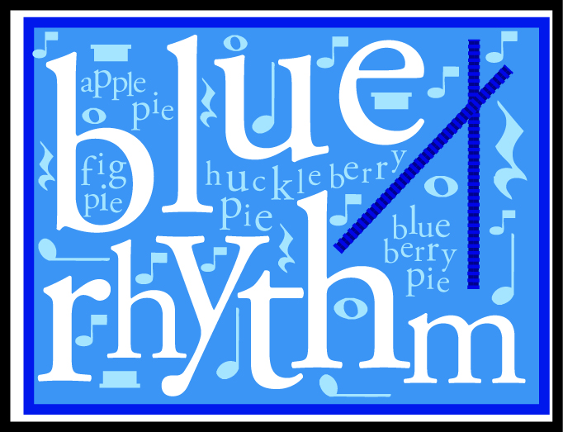 Mini Blue Rhythm: A one week course emphasizing beat and rhythm.

Scope and Sequence

 | Beat/Subdivisioin | Identification | Notation | Classical Form
Lesson 1 | Experience steady beat with entire body using various songs and activities  Experience the internal beat. | Imitate specific rhythmic patterns. | Introduce bug chant as precursor to rhythmic notation. | Introduce Triumphant March from Aida puppet show for study of motives and themes.
Lesson 2 | Produce steady beat and subdivide the beat.  More experience with internal beat. | Identify patterns and imitate with rhythm sticks. | Introduce ‘bug’ notation symbols in rhythmic chant. | Participate in show, reviewing rhythmic themes.
Lesson 3 | Subdivide beat into two and four parts using the full body. | Identify rhythmic patterns by sound. | Review rhythmic notation through interactive games. | Participate in rhythmic movements to enhance rhythm patterns in the piece.
Lesson 4 | Introduce abstract subdividing notation. Participate in beat and subdividing activities. | Identify bug rhythms within a song. | Read rhythm patterns from notation. | Review theme differentiation, theme repeats, patterns
Lesson 5 | Produce subdivisions of the beat.  Demonstrate understanding of internal beat. | Identify various rhythmic patterns in numerous songs and imitate them. | Read and perform various rhythm patterns from notation. | Perform Show, demonstrating knowledge of themes, motives and form.

Materials Fee: $18 for CD, rhythm sticks and flashcards.
Tuition: $25. (variable)
Royalty: $2.50 per student

